Name: Le Thanh Duc

Neptun: YZ49Y8

Labyrinth Homework:

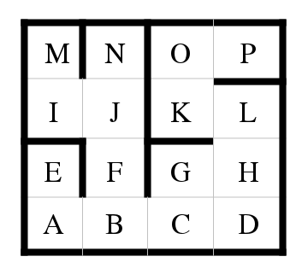

Starting point: A

End point/ Goal: P

Order: N, S, E, W

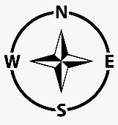

Steps:

A -> E -> Deadend -> backtrack A -> B -> F -> J -> N -> Deadend -> backtrack J -> I -> M -> Deadend -> backtrack B -> C -> G -> H -> L -> K -> O -> P

Route looks like:

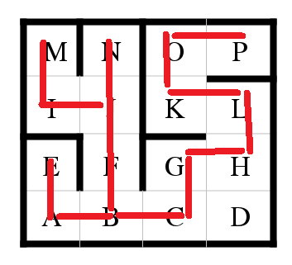How many steps are needed to achieve the goal? 18 steps (not include check Deadend steps)

How many backtracking steps are required? 3 steps